ExperimentNo :5
Date: 3/02 /2011
2-D TRANSFORMATIONS

PROBLEM DEFINITION

Write a program to implement the following 2D transformations on an assymmetric quadrilateral

- Translation
- Rotation
- Scaling
- Reflection

THEORETICAL BACKGROUND

Transformations are a fundamental part of computer graphics. Transformations are used to position objects, to shape objects, to change viewing positions, and even to change how something is viewed .
Translation:
Translation is applied to an object by repositioning it along a straight-line path from one coordinate location to another. We translate a two-dimensional point by adding translation distances , ta and tb, to the original coordinate position (x,y) to move the point to new position (x’,y’)

x’ = x + tx
y’ = y + ty

The translation distance pair (ta,tb) is called a translation vector or shift vector. We can express the translation equations as a single matrix equation by using column vectors to represent coordinate positions and the translation vector:

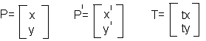

P’ = P + T

Here's the function that will allow us to do translations.
point2d Transform2d::TranslatePoint(float xdiff, float ydiff, point2d &point)
{
point2d newpoint;
newpoint.x=point.x+xdiff;
newpoint.y=point.y+ydiff;
return newpoint; }
This function allows us to add a certain amount to the x and y coordinates of a point, but notice that we don't do the alignment here, we'll get to that later.Also notice that we are preserving the value of the point passed to us,instead we create a newpoint and return that instead.

Before Translation After Translation

Each of the transformation is used to generate a new point (x’, y’) from the coordinates of a point t (x, y) in the original picture description. If the original definition includes a line, it suffices to apply the transformation to the endpoints of the line and display the line between the two transformed endpoints. Transformation is a function that maps every position (x, y) into a new position (x', y'). Instead of applying the transformation to every point in every line that makes up the object, we simply apply the function to the objects vertices and then draw new lines between the resulting new endpoints.
Rotation:
A two-dimensional rotation is applied to an object by repositioning it along a circular path in the xy plane.To generate a rotation , we specify a rotation angle θ and the position (xr,yr) of the rotation point about which the object is to be rotated. Positive values for the rotation angle define counterclockwise rotations about the pivot point and negative values rotate objects in the clockwise direction.This transformation can also be described as a rotation about a rotation axis that is perpendicular to the xy plane and passes through the pivot point.End-points of vectors in the xy-plane can be rotated to a new position by multiplying rotation factors to the coordinates of the end-points.For each end-point p(x, y) which is to be rotated by an angle θ about the origin to a new end-point p(x’, y’):
x’ = xcosθ - ysinθ
y’ = xsinθ + ycosθ

This can be rewritten in matrix form:

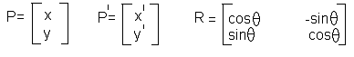
P’=R.P

Here's the function that will allow us to do rotations:
point2d Transform2d::Rotate(float angle,point2d &point)
{
float xold,yold;
point2d newpoint;
xold=point.x;
yold=point.y;
newpoint.x= xold*cos(angle)-yold*sin(angle);
newpoint.y= xold*sin(angle)+yold*cos(angle);
return newpoint;
}
This function, first save the old x and y coordinates and then use them in our equations. Remember that with these equations, the object will always be rotated around (0,0) so if you want something rotating about its own center and not be located at (0,0), you must first rotate it and then translate it. Also notice that we are returning a point instead of modifying the one passed to it. We are doing this because we always want to retain the positions of the original points. Modifying and saving the data to the same point will produce distorted, unreliable results.
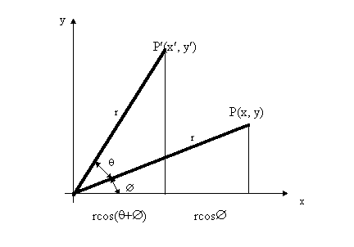
Scaling:
A scaling transformation alters the size of an object .This operation can be carried out for polygons by multiplying the coordinate values (x,y) of each vertex by scaling factors sx and sy to produce the transformed coordinates(x’,y’):
x’ = x Sx
y’ = y Sy

This can be rewritten in matrix form:

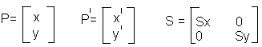
P’=S.P

Here's the function that will allow us to do scaling:
point2d Transform2d::Scale(float scale,point2d &point)
{
point2d newpoint;
newpoint.x= point.x*scale;
newpoint.y= point.y*scale;
return newpoint;
}

As you can see with this simple equation, if an object's points are not centered around (0,0) it will be hurled in a direction and look like its being translated and if it does manage to look scaled, it won't look correct. So, make sure that you objects are centered around (0,0).

Before scaling After scaling

Reflection:

To get the reflection about Y axis and X axis, first we splitting the entire screen into four equal parts by drawing X axis and Y axis. We het the resolution by calling the built in functions maxx() and maxy(). Then for the image about Y axisa add maxx/2 to every coordinates of the quadrillateral. The same procedure is used to find the reflection about X axis also taking maxy()/2 refference coordinates. The reflection perpendicular to origin can be calculated by taking reflection of reflection about Y axis refference with X axis.

ALGORITHM

Step 1: Start.
Step 2: Enter choice as 1 for Translation, 2 for Rotation, 3 for Scaling 4 for Reflection.
Step 3: if choice is 1 go to step 4 else goto step 5
Step 4:
- Accept coordinate of line as (xa,ya),(xb,yb)
- Accept translation factor as (tx,ty)
- Set xa as xa+tx
- Set xb as xb+tx
- Set ya as ya+ty
- Set yb as yb+ty
- Draw line with endpoints as (xa,ya) and (xb,yb)
- Stop

Step 5: if choice=2 continue; else go to step 6
- Accept coordinate of line as (xa,ya),(xb,yb)
- Accept angle of rotation as angle
- accept reference coordinate as (xl,yl)
- Set ang as (angle*3.14)/180
- Set x1 as xl+((xa-xl)*cos(ang))-((ya-yl)*sin(ang))
- Set y1 as yl+((xa-xl)*sin(ang))+((ya-yl)*cos(ang))
- Set x2 as xl+(((xb-xl)*cos(ang))-((yb-yl)*sin(ang)))
- Set y2 as yl+(((xb-xl)*sin(ang))+((yb-yl)*cos(ang)))
- Draw line with endpoints as (xa,ya) and (xb,yb)
- Stop

Step 6: if choice=3 continue; else goto step 7
- Accept coordinate of line as (xa,ya),(xb,yb)
- Accept scaling factor as (sx,sy)
- Set xa as xa*ts
- Set xb as xb*ts
- Set ya as ya*ts
- Set yb as yb*ts
- Draw line with endpoints as (xa,ya) and (xb,yb)
- Stop

Step 7:if choice=4 continue; else goto step 8
- Set temp as 240-yd1;
- Set yd1 as 240+temp;
- Set temp as 240-yd2;
- Set yd2 as 240+temp;
- Set temp as 240-yd3;
- Set yd3 as 240+temp;
- Set temp as 240-yd4;
- Set yd4 as 240+temp;
- Draw the quadrilateral
- Set temp as 320-xd1;
- Set xd1 as 320+temp;
- Set temp as 320-xd2;
- Set xd2 as 320+temp;
- Set temp as 320-xd3;
- Set xd3 as 320+temp;
- Set temp as 320-xd4;
- Set xd4 as 320+temp;
- Draw the quadrilateral
- Set temp as 240-yd1;
- Set yd1 as 240+temp;
- Set temp as 240-yd2;
- Set yd2 as 240+temp;
- Set temp as 240-yd3;
- Set yd3 as 240+temp;
- Set temp as 240-yd4;
- Set yd4 as 240+temp;

Step 8: Stop.

PROGRAM DEVELOPMENT

#include<stdio.h>
#include<stdlib.h>
#include<math.h>
#include<graphics.h>
#include<conio.h>
void main()
{
int gdriver=DETECT,gnode,choice,errorcode;
float xr,yr,temp1,temp2,x1,x2,x3,y1,y2,y3,tx,ty,sx,sy;
float ang,temp,xd1,yd1,xd2,yd2,xd3,yd3,xd4,yd4;
initgraph(&gdriver,&gnode,"");
printf("\n1.translation\n2.rotation\n3.scaling\n4.reflection\n");
printf("enter your choice\n");
scanf("%d",&choice);
if(choice==1)
{
printf("enter the (x,y) coordinates of the triangle\n");
scanf("%f %f %f %f %f %f ",&x1,&y1,&x2,&y2,&x3,&y3);
printf("enter the translation factors\n");
scanf("%f %f",&tx,&ty);
cleardevice();
line(x1,y1,x2,y2);
line(x2,y2,x3,y3);
line(x3,y3,x1,y1);
x1=x1+tx;
x2=x2+tx;
x3=x3+tx;
y1=y1+ty;
y2=y2+ty;
y3=y3+ty;
4=y4+ty;
line(x1,y1,x2,y2);
line(x2,y2,x3,y3);
line(x3,y3,x1,y1);
}
else if (choice==2)
{
printf("enter the (x,y) coordinates of the triangle\n");
scanf("%f%f%f%f%f%f ",&x1,&y1,&x2,&y2,&x3,&y3);
printf("enter angle of rotation\n");
scanf("%f",&ang);
printf("enter the reference points\n");
scanf("%f%f",&xr,&yr);
cleardevice();
line(x1,y1,x2,y2);
line(x2,y2,x3,y3);
line(x3,y3,x1,y1);
ang=(ang*3.14)/180;
temp1=x1;
temp2=y1;
x1=xr+((temp1-xr)*cos(ang))-((temp2-yr)*sin(ang));
y1=yr+((temp1-xr)*sin(ang))+((temp2-yr)*cos(ang));
temp1=x2;
temp2=y2;
x2=xr+((temp1-xr)*cos(ang))-((temp2-yr)*sin(ang));
y2=yr+((temp1-xr)*sin(ang))+((temp2-yr)*cos(ang));
temp1=x3;
temp2=y3;
x3=xr+((temp1-xr)*cos(ang))-((temp2-yr)*sin(ang));
y3=yr+((temp1-xr)*sin(ang))+((temp2-yr)*cos(ang));
line(x1,y1,x2,y2);
line(x2,y2,x3,y3);
line(x3,y3,x1,y1);
}
else if(choice==3)
{
printf("enter the (x,y) coordinates of the quadrilateral\n");
scanf("%f %f %f %f %f %f ",&x1,&y1,&x2,&y2,&x3,&y3);
printf("enter the scaling factors\n");
scanf("%f %f",&sx,&sy) ;
cleardevice();
line(x1,y1,x2,y2);
line(x2,y2,x3,y3);
line(x3,y3,x1,y1);
x1=x1*sx;
x2=x2*sx;
x3=x3*sx;
x4=x4*sx;
y1=y1*sy;
y2=y2*sy;
y3=y3*sy;
y4=y4*sy;
line(x1,y1,x2,y2);
line(x2,y2,x3,y3);
line(x3,y3,x1,y1);
}
else if(choice==4)
{
int rfl;
printf("enter the (x,y) coordinates of the quadrilateral\n");
scanf("%f %f %f %f %f %f ",&x1,&y1,&x2,&y2,&x3,&y3);
printf(“Reflection about: 1. x-axis 2. y-axis 3. origin\n”);
scanf(“%d”,&rfl);
if(rfl==1){ xd1=x1;
yd1=y1;
xd2=x2;
yd2=y2;
xd3=x3;
yd3=y3;
line(xd1,yd1,xd2,yd2);
line(xd2,yd2,xd3,yd3);
line(xd3,yd3,xd1,yd1);
line(0,240,638,240);
line(320,0,320,638); }
if(rfl==2) { temp=240-yd1;
yd1=240+temp;
temp=240-yd2;
yd2=240+temp;
temp=240-yd3;
yd3=240+temp;
line(xd1,yd1,xd2,yd2);
line(xd2,yd2,xd3,yd3);
line(xd3,yd3,xd1,yd1);
xd1=x1;
yd1=y1;
xd2=x2;
yd2=y2;
xd3=x3;
yd3=y3;
temp=320-xd1;
xd1=320+temp;
temp=320-xd2;
xd2=320+temp;
temp=320-xd3;
xd3=320+temp;
line(xd1,yd1,xd2,yd2);
line(xd2,yd2,xd3,yd3);
line(xd3,yd3,xd1,yd1);
}
if(rfl==3){ temp=240-yd1;
yd1=240+temp;
temp=240-yd2;
yd2=240+temp;
temp=240-yd3;
yd3=240+temp;
line(xd1,yd1,xd2,yd2);
line(xd2,yd2,xd3,yd3);
line(xd3,yd3,xd1,yd1);
} } getch(); }

TESTING STRATEGIES

Test Case 1:
To perform translation on a triangle.
Test Case 2:
To rotate a triangle in a particular angle.
Test Case 3:
To perform scaling on a triangle.
Test Case 4:
To perform reflections
    - About the X-Axis
    - About the Y-Axis
    - About the origin

SUMMARY OF RESULTS

Case 1: 1.translation
2.rotation
3.scaling
4.reflection
enter your choice
1
enter the (x,y) coordinates of the quadrilateral
100 100 100 300 300 170
enter the translation factors
100 100
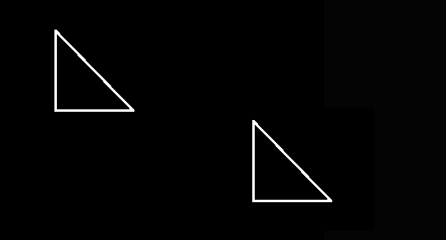

Case 2: 1.translation
2.rotation
3.scaling
4.reflection
enter your choice
2
enter the (x,y) coordinates of the quadrilateral
100 100 200 30 300 170
enter angle of rotation
30
enter the reference points
  - 100

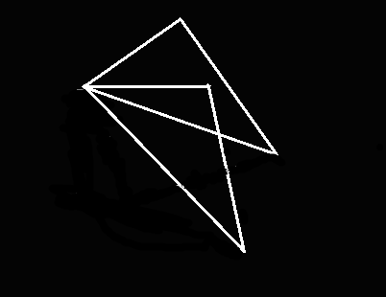

Case 3: 1.translation
2.rotation
3.scaling
4.reflection
enter your choice
3
enter the (x,y) coordinates of the quadrilateral
100 100 100 300 300 170
enter the scaling factors
2 2
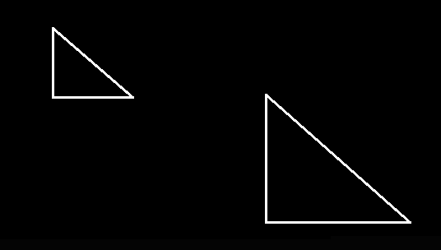

Case 4: (i) 1.translation
2.rotation
3.scaling
4.reflection
enter your choice
4
enter the (x,y) coordinates of the quadrilateral
100 100 100 300 300 170
Reflection about: 1. x-axis 2. y-axis 3. origin
1

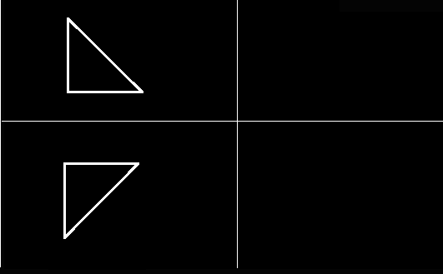

(ii) 1.translation
2.rotation
3.scaling
4.reflection
enter your choice
4
enter the (x,y) coordinates of the quadrilateral
100 100 100 300 300 170
Reflection about: 1. x-axis 2. y-axis 3. origin
2

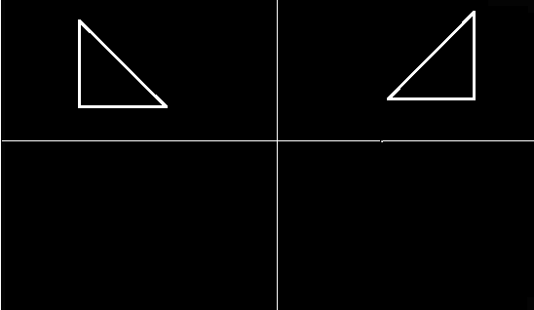

(iii) 1.translation
2.rotation
3.scaling
4.reflection
enter your choice
4
enter the (x,y) coordinates of the quadrilateral
100 100 100 300 300 170
Reflection about: 1. x-axis 2. y-axis 3. origin
3

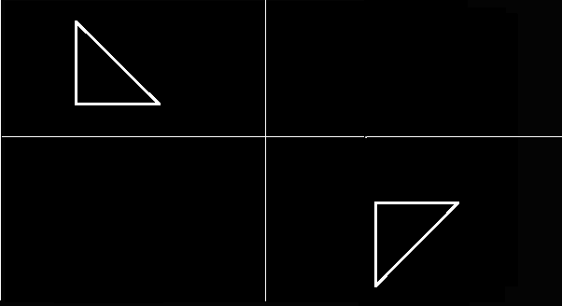

CONCLUSION

The program to demonstrate various 2D transformations was implemented successfully and the results were obtained accurately. The various transformations implemented in this program were translation, rotation and scaling.

Program No: 6
Date: 27-01-2011

LINE CLIPPING

PROBLEM DEFINITION

Write a program to implement Cohen-Sutherland line clipping algorithm.

THEORETICAL BACKGROUND

The Cohen-Sutherland algorithm is one of the oldest and most popular line clipping procedures. Every line end point in a picture ia assigned a four digit binary code,called a region code, that identifies the location of the point relative to the boundaries of the clipping rectangle.Each bit position in the region code is used to indicate one of the four relative position of the points with respect to the clip window.

Bit 1:left,Bit 2:right,Bit 3:below,Bit 4:above.

The Cohen-Sutherland algorithm uses a divide-and-conquer strategy. The line segment's endpoints are tested to see if the line can be trivally accepted or rejected. If the line cannot be trivally accepted or rejected, an intersection of the line with a window edge is determined and the trivial reject/accept test is repeated. This process is continued until the line is accepted.

To perform the trivial acceptance and rejection tests, we extend the edges of the window to divide the plane of the window into the nine regions. Each end point of the line segment is then assigned the code of the region in which it lies.

- Given a line segment with endpoint P1=(x1,y1)and P2=(x2,y2)
- Compute the 4-bit codes for each endpoint.
If both codes are 0000,(bitwise OR of the codes yields 0000 ) line lies completely inside the window: pass the endpoints to the draw routine.
If both codes have a 1 in the same bit position (bitwise AND of the codes is not 0000), the line lies outside the window. It can be trivially rejected.
- If a line cannot be trivially accepted or rejected, at least one of the two endpoints must lie outside the window and the line segment crosses a window edge. This line must be clipped at the window edge before being passed to the drawing routine.
- Examine one of the endpoints, say P1=(x1,y1). Read P1's 4-bit code in order: Left-to-Right, Bottom-to-Top.
- When a set bit (1) is found, compute the intersection I of the corresponding window edge with the line from P1toP2. Replace P1with I and repeat the algorithm.

Display Window

-A section of a 2D scene that is selected for display
-All parts of the scene outside the selected section are “clipped”
-Selects what we want to see

View Port
-Control the placement within the display window
-Indicates where an object is to be viewed in the output device

ALGORITHM

Step 1: Start.
Step 2: Enter the coordinates of the line x0, y0, x1, y1.
Step 3: Enter the coordinates of the window xwmin, ywmin, xwmax, ywmax.
Step 4: Compute 4 bit code for each end point.
Step5: If both codes are 0000(bitwise OR of the code yield 0000) line lies completely
inside the window, draw the line. If both codes have 1 in the same bit position(bitwise AND of the codes is not 0000) the line lies outside the window. It can be trivially rejected.
Step 6: If a line cannot be trivially accepted or rejected, atleast one of the two endpoints must
be outside the window and the line segment crosses a window edge. This line must
be clipped at the window edge before being passed to the drawing routine.
Step 7: Examine one of the endpoints say p1=(x0,y0) read p1’s 4bit code on order left to
right, bottom to top
Step 8: When a set bit(1) is found compute the intersection I of the corresponding window
edge with the line from p1 o p2. Replace p1 with I and repeat the algorithm
Step 9: Stop

PROGRAM DEVELOPMENT

#include<stdio.h>
#include<graphics.h>
typedef unsigned int outcode;
enum { TOP=0x1, BOTTOM=0x2, RIGHT=0x4, LEFT=0x8 };
int calcode (float x,float y,float xwmin,float ywmin,float xwmax,float ywmax)
{
int code =0;
if(y> ywmax)
code |=TOP;
else if( y<ywmin)
code |= BOTTOM;
else if(x > xwmax)
code |= RIGHT;
else if ( x< xwmin)
code |= LEFT;
return(code);
}

void lineclip(float x0,float y0,float x1,float y1,float xwmin,float ywmin,float xwmax,float ywmax )
{
int gd,gm;
outcode code0,code1,codeout;
int accept = 0, done=0;

code0 = calcode(x0,y0,xwmin,ywmin,xwmax,ywmax);
code1 = calcode(x1,y1,xwmin,ywmin,xwmax,ywmax);
do{
if(!(code0 | code1))
{ accept =1 ; done =1; }
else
if(code0 & code1) done = 1;
else
{
float x,y;
codeout = code0 ? code0 : code1;
if(codeout & TOP)
{
x = x0 + (x1-x0)*(ywmax-y0)/(y1-y0);
y = ywmax;
}
else
if( codeout & BOTTOM)
{
x = x0 + (x1-x0)*(ywmin-y0)/(y1-y0);
y = ywmin;
}
else
if ( codeout & RIGHT)
{
y = y0+(y1-y0)*(xwmax-x0)/(x1-x0);
x = xwmax;
}
else
{
y = y0 + (y1-y0)*(xwmin-x0)/(x1-x0);
x = xwmin;
}
if( codeout == code0)
{
x0 = x; y0 = y;
code0=calcode(x0,y0,xwmin,ywmin,xwmax,ywmax);
}
else
{
x1 = x; y1 = y;
code1 = calcode(x1,y1,xwmin,ywmin,xwmax,ywmax);
}
}
} while( done == 0);
if(accept) line(x0,y0,x1,y1);
rectangle(xwmin,ywmin,xwmax,ywmax);

getch();

}
void main()
{
float x2,y2,x1,y1,xwmin,ywmin,xwmax,ywmax;
int gd,gm;
detectgraph(&gd,&gm);
initgraph(&gd,&gm,"C:\\TC\\BGI");
printf("\n\n\tEnter the co-ordinates of Line :");
printf("\n\n\tX1 Y1 : ");
scanf("%f %f",&x1,&y1);
printf("\n\n\tX2 Y2 : ");
scanf("%f %f",&x2,&y2);
printf("\n\tEnter the co_ordinates of window :\n ");
printf("\n\txwmin , ywmin : ");
scanf("%f %f",&xwmin,&ywmin);
printf("\n\txwmax , ywmax : ");
scanf("%f %f",&xwmax,&ywmax);
line(x1,y1,x2,y2);
rectangle(xwmin,ywmin,xwmax,ywmax);
getch();
cleardevice();
lineclip(x1,y1,x2,y2,xwmin,ywmin,xwmax,ywmax );
getch();
closegraph();
}

TESTING STRATEGIES

Test Case 1: A line outside the clipping window.
Test Case 2: A line which is clipped by the window
Test Case 3: A line which is clipped by the window

SUMMARY OF RESULTS

Case 1:

Enter the co-ordinates of Line :
X1 Y1 : 100 100
X2 Y2 : 100 400
Enter the co_ordinates of window :
xwmin , ywmin : 200 200
xwmax , ywmax : 300 350

Before clipping:
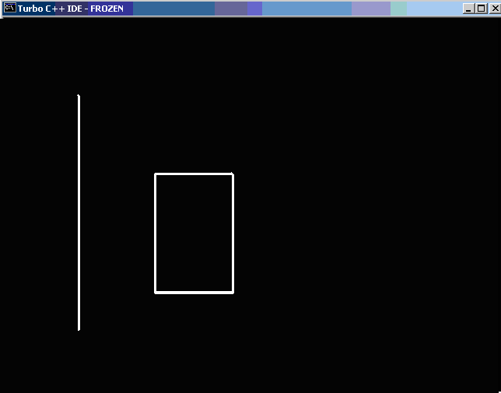

After clipping:
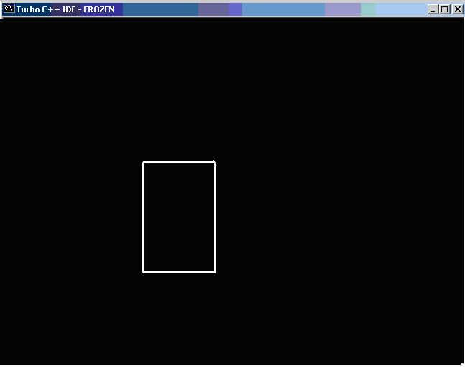

Case 2:
Enter the co-ordinates of Line :
X1 Y1 : 100 100
X2 Y2 : 500 500
Enter the co_ordinates of window :
xwmin , ywmin : 200 200
xwmax , ywmax : 300 350

Before clipping:
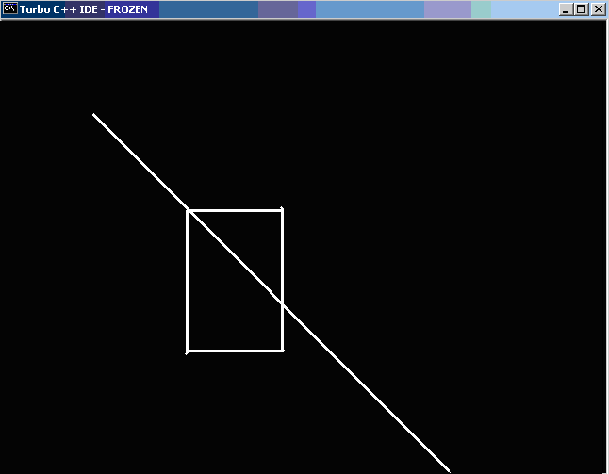

After clipping:
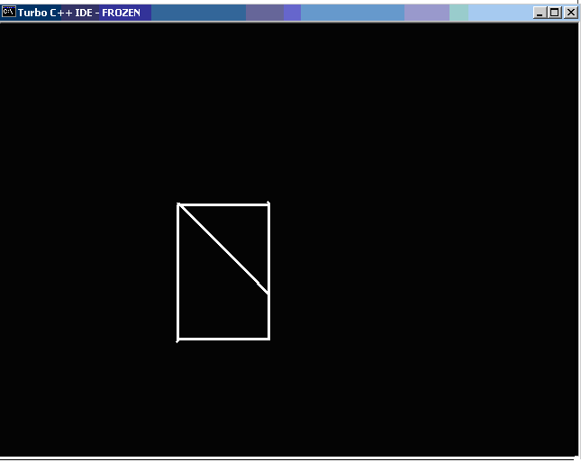

Case 3:
Enter the co-ordinates of Line :
X1 Y1 : 100 250
X2 Y2 : 500 250
Enter the co_ordinates of window :
xwmin , ywmin : 200 200
xwmax , ywmax : 300 350

Before clipping:
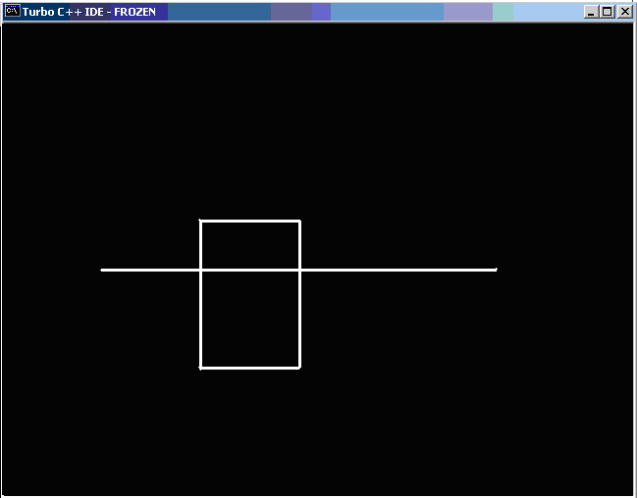

After clipping:
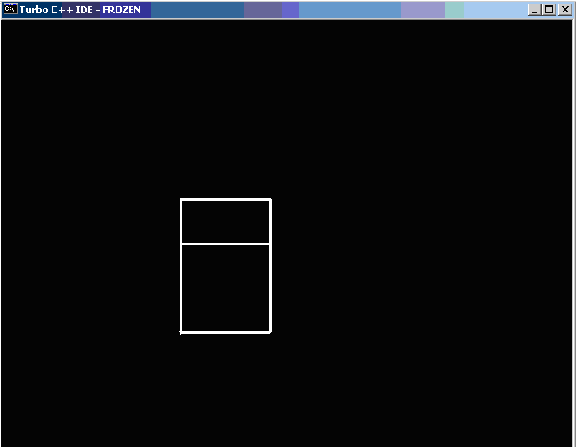

CONCLUSION

The algorithm to implement Cohen-Sutherland line clipping was written and program code was developed. The results were obtained and verified to be correct.

